PL/SQL Advanced part 5

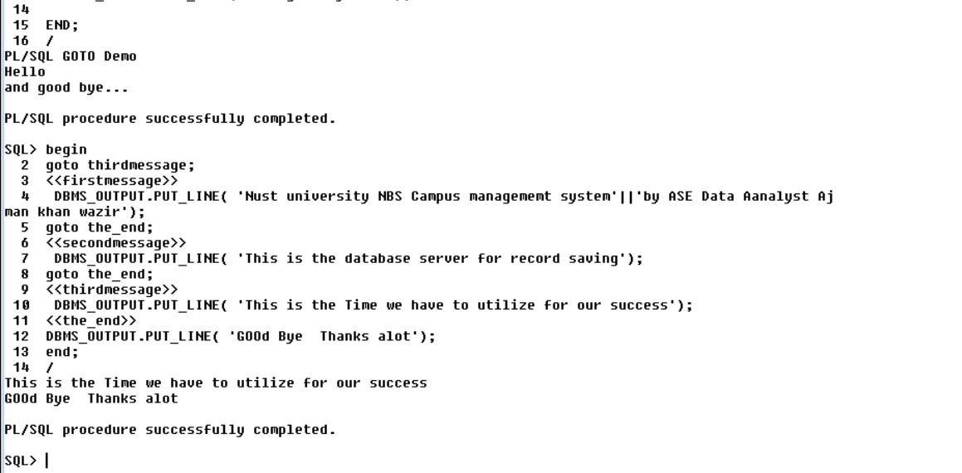First, you cannot use a GOTO statement to transfer control into an [IF](https://www.oracletutorial.com/plsql-tutorial/plsql-if/), [CASE](https://www.oracletutorial.com/plsql-tutorial/plsql-case-statement/) or [LOOP](https://www.oracletutorial.com/plsql-tutorial/plsql-loop/) statement, the same for sub-block.

The following example attempts to transfer control into an IF statement using a GOTO statement:

DECLARE

n_sales NUMBER;

n_tax NUMBER;BEGIN

GOTO inside_if_statement;

IF n_sales > 0 THEN

<<inside_if_statement>>

n_tax := n_sales * 0.1;

END IF;END;

Code language: SQL (Structured Query Language) (sql)

Oracle issued the following error:

PLS-00375: illegal GOTO statement; this GOTO cannot branch to label 'INSIDE_IF_STATEMENT'

Code language: SQL (Structured Query Language) (sql)

Second, you cannot use a GOTO statement to transfer control from one clause to another in the IF statement e.g., from IF clause to ELSIF or ELSE clause, or from one WHEN clause to another in the CASE statement.

The following example attempts to transfer control to a clause in the IF statement:

DECLARE

n_sales NUMBER;

n_commission NUMBER;BEGIN

n_sales := 120000;

IF n_sales > 100000 THEN

n_commission := 0.2;

GOTO zero_commission;

elsif n_sales > 50000 THEN

n_commission := 0.15;

elsif n_sales > 20000 THEN

n_commission := 0.1;

ELSE

<<zero_commission>>

n_commission := 0;

END IF;END;

Code language: SQL (Structured Query Language) (sql)

Oracle issued the following error.

PLS-00375: illegal GOTO statement; this GOTO cannot branch to label 'ZERO_COMMISSION'

Code language: SQL (Structured Query Language) (sql)

Third, you cannot use a GOTO statement to transfer control out of a subprogram or into an [exception handler](https://www.oracletutorial.com/plsql-tutorial/plsql-exception/).

Fourth, you cannot use a GOTO statement to transfer control from an exception handler back into the current block.

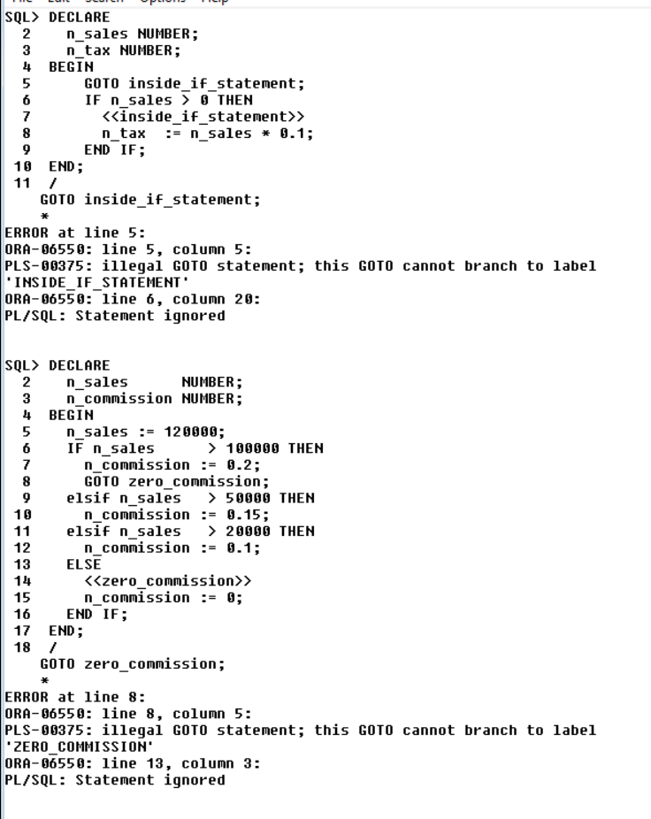The NULL statement is a NULL keyword followed by a semicolon ( ;). The NULL statement does nothing except that it passes control to the next statement.

The NULL statement is useful to:

* Improve code readability
* Provide a target for a [GOTO](https://www.oracletutorial.com/plsql-tutorial/plsql-goto/) statement
* Create placeholders for subprograms

## Improving code readability

The following code sends an email to employees whose job titles are Sales Representative

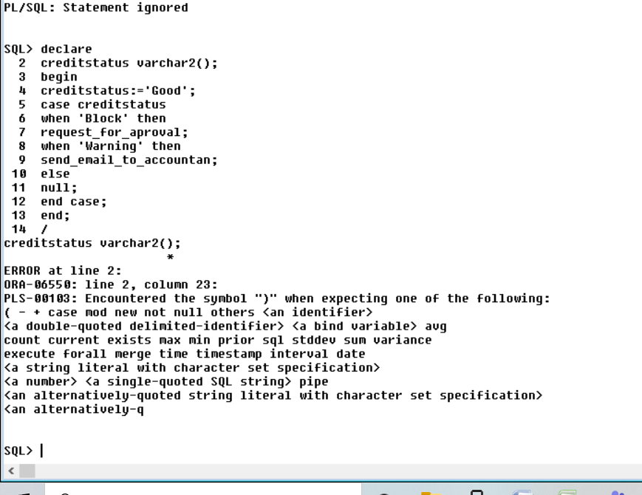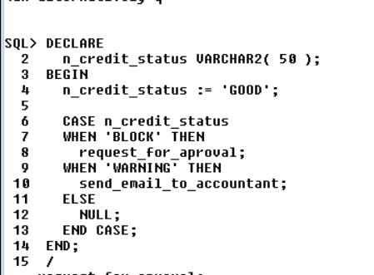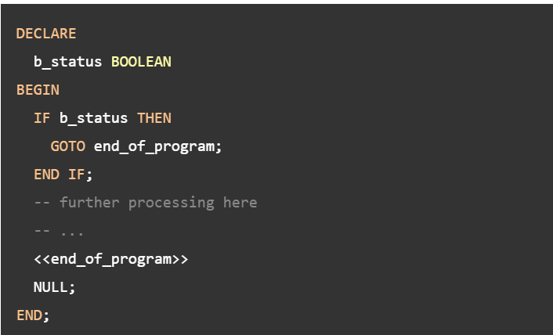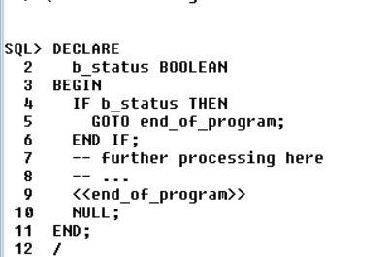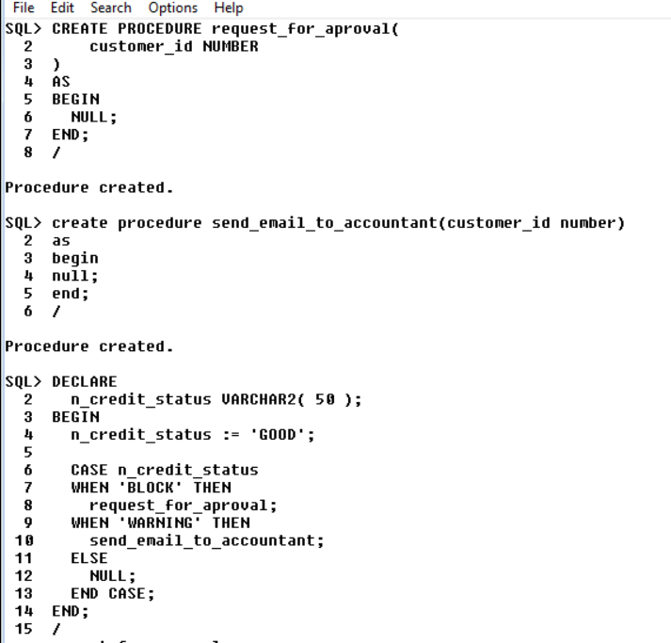

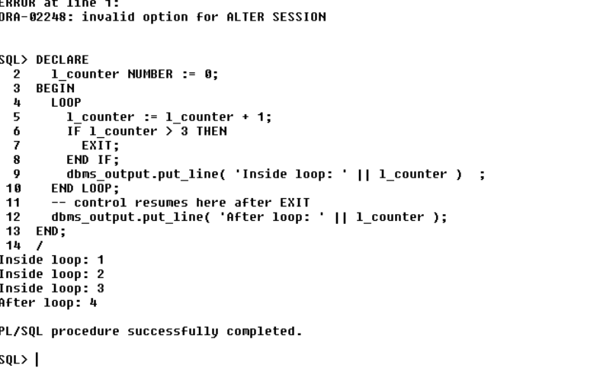The following explains the logic of the code:

* First, declare and initialize a [variable](https://www.oracletutorial.com/plsql-tutorial/plsql-variables/) l_counter to zero.
* Second, increase the l_counter by one inside the loop and exit the loop if the l_counter is greater than three. If the l_counter is less than or equal three, show the l_counter value. Because the initial value of  l_counter is zero, the code in the body of the loop executes three times before it is terminated.
* Third, display the value of the l_counter after the loop.

